**///** /Thematic workshop 3 OSLO Air & Water/

**////////////////////////////////////////////////////////////////////////////////////////////////////////**

**Datum**: 01/04/2021: 13:00 – 15:30 CET

**Locatie**: Online - Microsoft Teams Meeting

|  |  |
| --- | --- |
| **Belgian national & regional governments** | Michiel De Keyzer - Digitaal Vlaanderen  Kevin Haleydt - Digitaal Vlaanderen Jurgen Meirlaen, Vlaamse Milieumaatschappij  Geert Van Haute, Departement Omgeving  Greet Devriese, Vlaamse Milieumaatschappij  Frank Lavens, Vlaamse Milieumaatschappij  Geert Thijs, OSLO-team, Digitaal Vlaanderen |
| **Local administration Europe** | Benjamin Gärtner, City of Heidelberg, Germany |
| **Research institutions** | Fernando López, FIWARE Foundation, Germany |
| **Other** | Elien Dewitte - VLIZ - Beligum Laurian Van Maldeghem, Flanders Marine Institute (VLIZ),  Belgium |

**////////////////////////////////////////////////////////////////////////////////////////////////////////**

# Agenda of the workshop

|  |  |  |
| --- | --- | --- |
| **Topic** | **Time (mins)** | **Timestamps** |
| **Start TW2** | 5 mins | 13:05 |
| **Introduction & Who’s in the room** | 5 mins | 13:10 |
| **TW2 Github Issues** | 30 mins | 13:40 |
| **Changes to the models since TW2** | 10 mins | 13:50 |
| **Break** | 10 mins | 14:00 |
| **Brainstorm exercise Attributes** | 60 mins | 15:00 |
| **Validation Definitions** | 10 min | 15:15 |
| **Next Steps** | 5 min | 15:30 |

1. **Introduction & who’s in the room**

We started the workshop with detailing the purpose of the workshop and the agenda (above). The purpose of the workshop was fourfold, namely:

* Giving a recap of the First thematic workshop;
* Going over the changes to core, air & water model since last workshop;
* Addressing specific questions and remarks asked in TW2; and
* Detailing the collaboration for definitions.

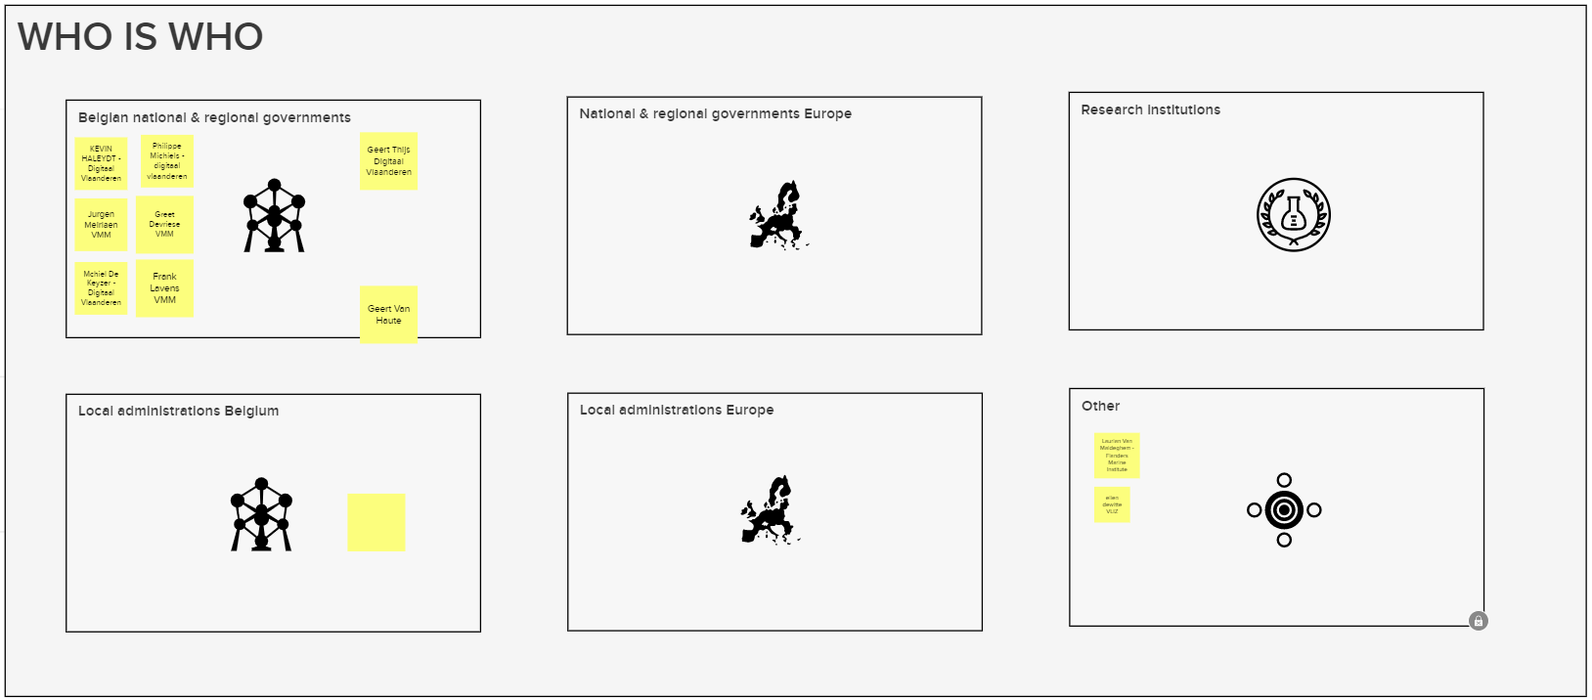

1. **Recap of TW2**

We started the workshop with addressing the 5 open questions at the end of Thematic Workshop 2. As we did not have time last workshop to properly address these questions, we analysed the issues and proposed a proper solution for each of the questions.

1. Observed Properties ([Link](https://github.com/Informatievlaanderen/OSLOthema-airAndWater/issues/2))

With regards to the observed properties, we received the input last thematic workshop that we needed to indicate a standardized code list to use but also leave the flexibility to define other properties should they not be present int the code list that is proposed.

|  |  |  |  |
| --- | --- | --- | --- |
| Proposed lists | AIR | WATER | BIOLOGY |
| [CAS](https://www.cas.org/support/documentation/chemical-substances/faqs#:~:text=A%20CAS%20Registry%20Number%20is,CAS%20Registry%20Number%20for%20caffeine.) | X | X |  |
| [PubChem](https://pubchem.ncbi.nlm.nih.gov/compound/Phosphoric-acid) | X | X |  |
| [WISE](http://dd.eionet.europa.eu/dataelements/75873) |  | X |  |
| [Darwin Core - GBIF](https://www.gbif.org/dataset/search?type=CHECKLIST) |  | X | X |
| [Wikidata](https://www.wikidata.org/wiki/Wikidata:Main_Page) | X | X | X |

As indicated in the table above, several code lists were proposed by the participants. We thoroughly analysed them and noticed that only one code list allows to link to substances or determinants that apply to air, water **and biological indicators**, namely Wikidata. Wikidata also links to external code lists by their identifiers (see example below).

Example of biological indicator: an observation of Tubificidae & BelgianBioticIndex.

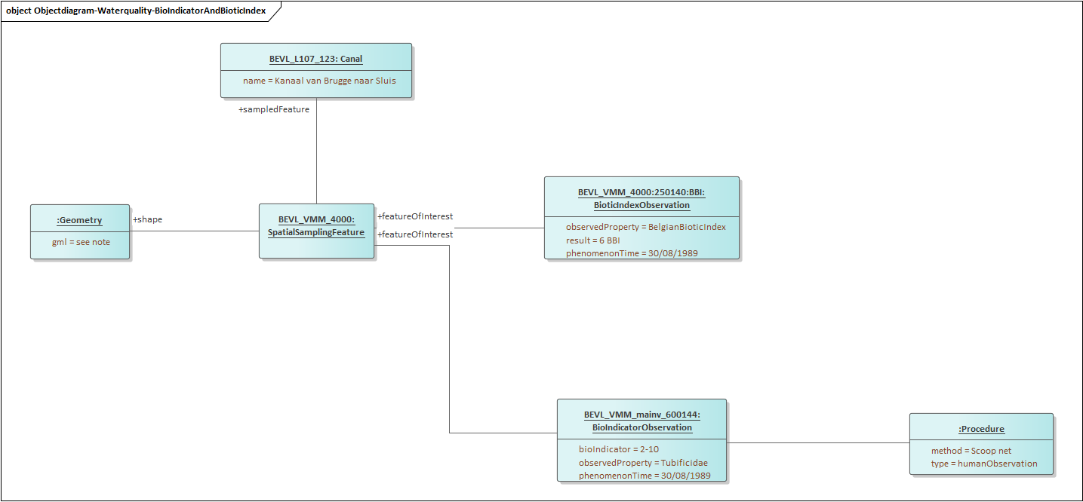

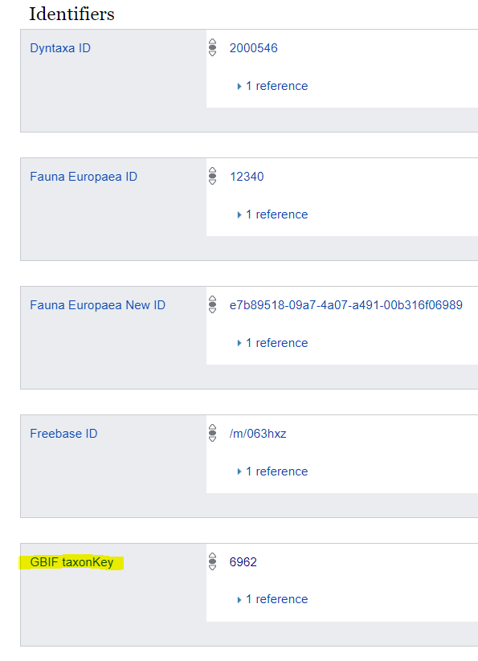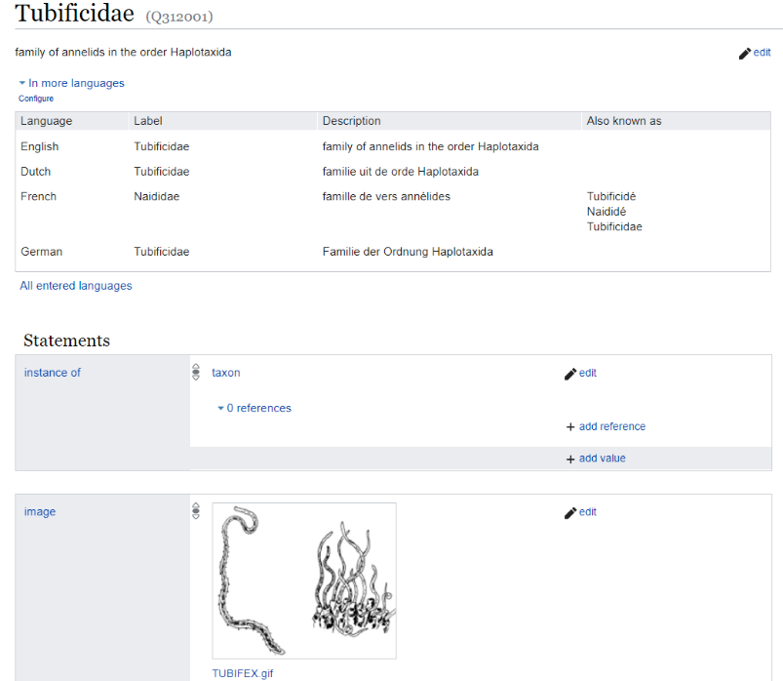When looking up the wikidata url (<https://www.wikidata.org/wiki/Q312001>), we can see a description of the Tubificidae as well as links to for example GBIF taxonomy.

We identified three ways to include this in the model:

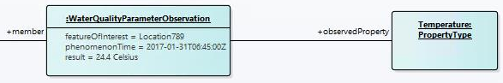1. PropertyType as a generic property class

2. PropertyType as a generic property class with the possibility to specify the type

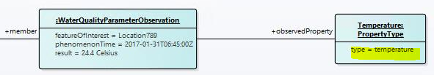

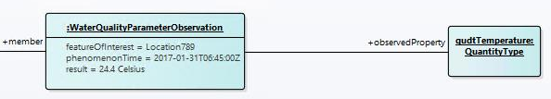3. Substitution of PropertyType by a virtual subclass like skos:Concept or some other class from a suitable vocabulary (like qudt:QuantityType)

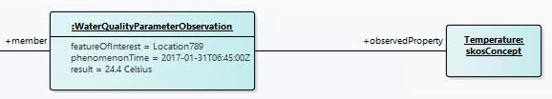

**This change was approved in the workshop and will be added to the model.**

2. Sampled Feature ([Link](https://github.com/Informatievlaanderen/OSLOthema-airAndWater/issues/3))

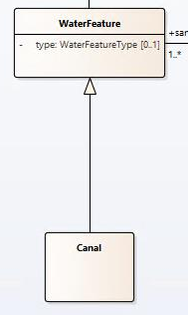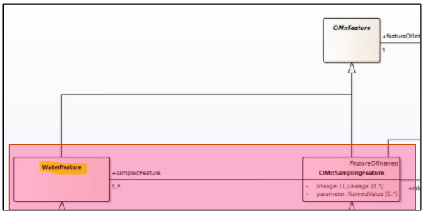The current model specifies a Sampling Feature from the abstract class OM::Feature. However we still lack a way to point towards the domain feature we are sampling (are we for example sampling a lake, a river…?). Therefore we proposed adding a new class called WaterFeature or AirFeature for the water and air models respectively.

However this change in itself is not sufficient. Therefore we would allow the model allow for two different types of giving more information on the domain feature that is being sampled:

1. We’ll add a ‘type’ attribute to the WaterFeature & AirFeature classes. In this type we would be able to mention the domain that is being observed
2. We allow the creation of instances of a subclass to specify the object we’re sampling. This means that you’ll be able to further specify the WaterFeature or AirFeature with a specific class. In the example above, you can see the addition of a ‘Canal’ class.

**This change was approved in the workshop and will be added to the model.**

In extension of this change, we will also need to specify which types of water- or air feature can be observed. The choice was made here to specify in the usage notes which is the preferred list of Feature types rather than making our own code list.

3. Sampling Feature ([Link](https://github.com/Informatievlaanderen/OSLOthema-airAndWater/issues/4))

There was also a need for a distinction between the SpatialSamplingFeature and the actual samples that are taken to for example the lab. In the WISE model, we noticed that the model allows pointing towards physical samples named ‘Specimen’. Although there was some initial discussion on the term ‘Specimen’, this change was accepted by the group.

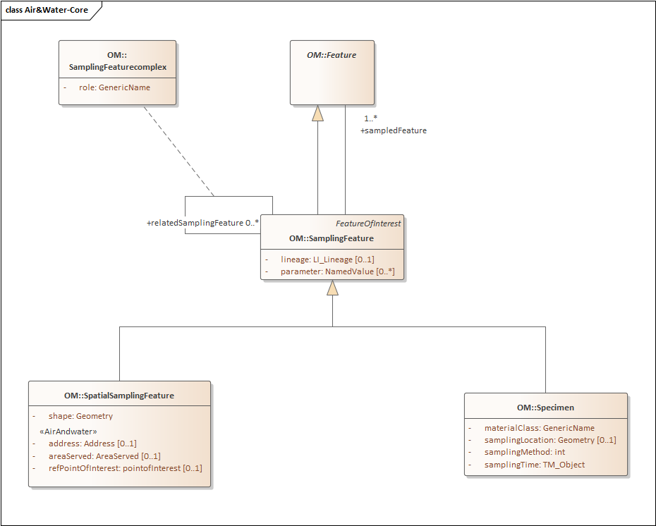

4. Observation Subtypes ([Link](https://github.com/Informatievlaanderen/OSLOthema-airAndWater/issues/5))

Another suggestion was that we want to expand the Observation class with other subtypes on top of Measurement & CategoryObservation. This would allow the users to specify different type of observation other than those already specified in the model.

The full list of subtypes we want to add (based on ISO O&M) is:

* Measurement (**value + unit**)
* CategoryObservation (**classification**)
* CountObservation (**count**)
* TruthObservation (**boolean**)
* TemporalObservation (**when** does the observed characteristics occur)
* GeometryObservation (**where** does the observation occur)
* ComplexObservation (**complex results**)
* DiscreteCoverageObservation (**temporal  or spatial coverage**)

**This change was also approved by the participants of the workshop.**

5. Observation Collections ([Link](https://github.com/Informatievlaanderen/OSLOthema-airAndWater/issues/6))

Last workshop we clarified there was a need for grouping observations and added the ObservationCollection to the model based on the SOSA-extensions. Additionally qb:Slice was also mentioned in prior workshops so we investigated the differences with ObservationCollections and what the addition would mean for our model.

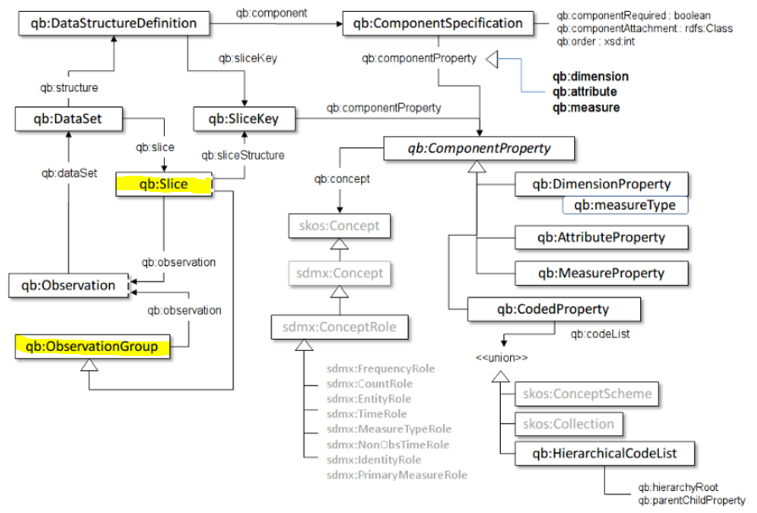

We noticed that Cube talks about qb:Slice as well as a qb:ObservationGroup. This ObservationGroup (a, possibly arbitrary, group of observation) seems to align with what is meant with an ObservationCollection in the SOSA extensions. This means that if we would want to add a qb:Slice to the model, this would be possible by adding it as a specialisation of ObservationCollection.

**Adding qb:Slice was approved by the participants of the workshop.**

1. **Changes to the core, Air & Water model**

This section will mention the changes to the model since last thematic workshop. Note that the full models will be added to the Github page where you’ll be able to get a better view on them. You can find the via the following [LINK](https://github.com/Informatievlaanderen/OSLOthema-airAndWater/tree/master/Thematic%20Workshop%203).

Core Model

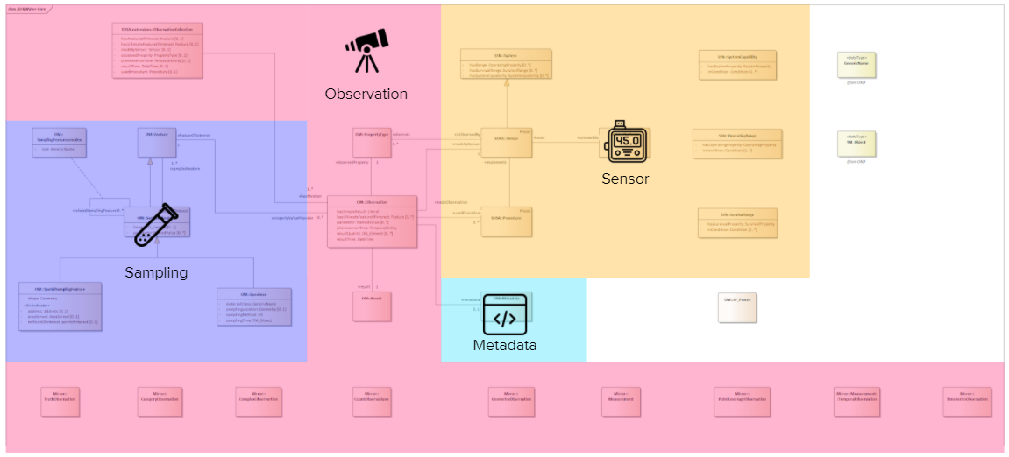

Changes:

* Changes to Sampling
  + Addition of OM:Specimen
  + Addition of OM::SamplingFeatureComplex which allows grouping of sampling feature and specimens
* Changes to Obserbation
  + Addition of the different subtypes
* Changes to Sensor
  + Removal of FIWARE:Device from the model

Air Model

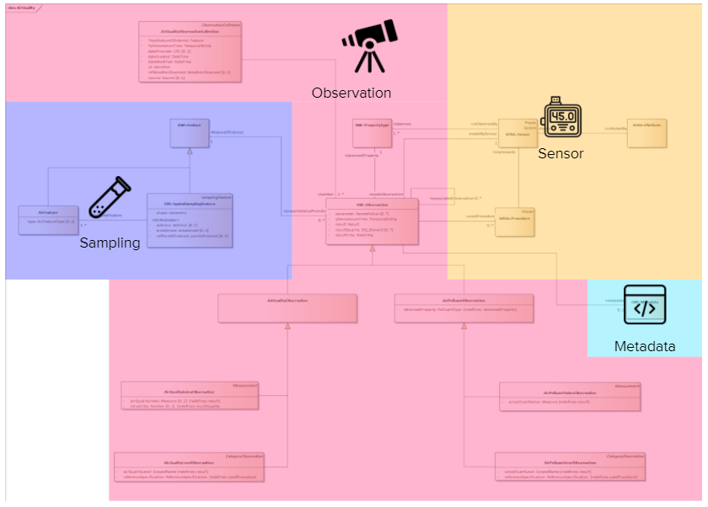

Changes:

* Addition of the AirFeature which allows to give more information on the actual domain feature type we’re observing and not only the spatial sample or specimen

Water model:

Changes:

* Addition of the WaterFeature which allows to give more information on the actual domain feature type we’re observing and not only the spatial sample or specimen
* Addition of observation of biological properties via **BioIndicatorObservation (countObservation)** and **BioIndexObservation (Measurement)**

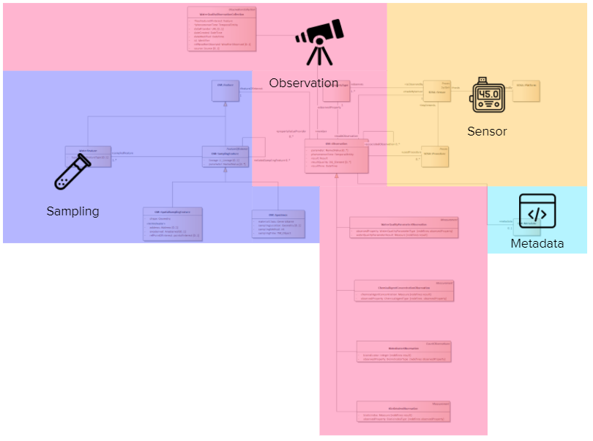

1. **Breakout session**

After the presentation of the changes to the model, a brainstorm session was organized to capture input on the attributes. This was done in Mural and the output can be seen on the [following location](https://app.mural.co/t/beadvtc7549/m/beadvtc7549/1617019110779/e542a4d6a6ea51377ef244c8368b807413edc533).

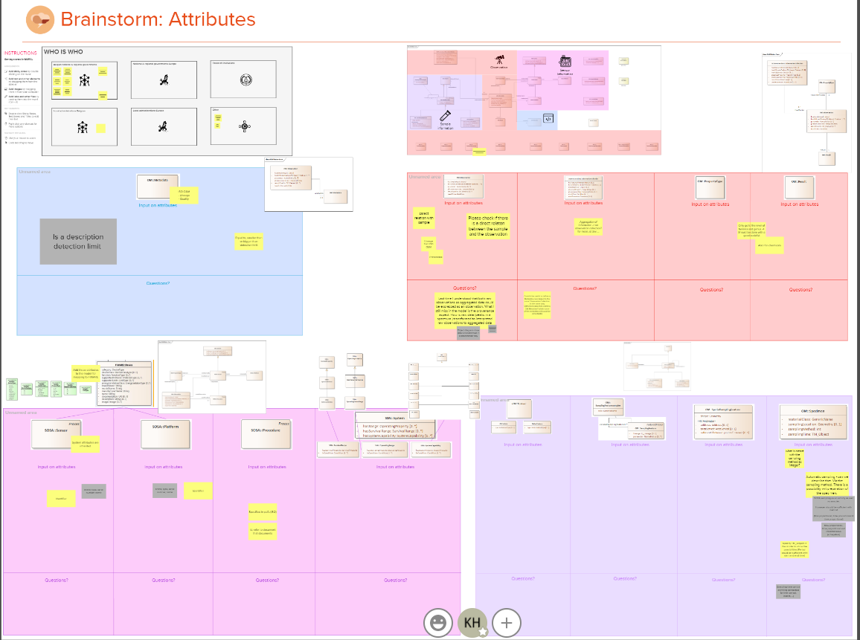

1. **Definitions**

The main definitions of the important classes are published on Github. The participants of the working group will need to double check these definitions and provide their feedback where needed. The list of definitions can be found [here](https://github.com/Informatievlaanderen/OSLOthema-airAndWater/tree/master/Thematic%20Workshop%203).

1. **Next steps**

* The next workshop is planned on April 27th, 2021 from 13h to 15h30. Don’t forget to subscribe if you haven’t already via the following [**LINK**](https://overheid.vlaanderen.be/informatie-vlaanderen/agenda/thematic-workshop-4-oslo-air-water). To subscribe you will need to click on the ‘Schrijf je in’ button and complete the form.
* If you have feedback on the models or other issues that you think should be addressed, please log these as issues on Github ([**https://github.com/Informatievlaanderen/OSLOthema-airAndWater**](https://github.com/Informatievlaanderen/OSLOthema-airAndWater))or send them via email to [kevin.haleydt@vlaanderen.be](mailto:kevin.haleydt@vlaanderen.be)
* You will also find the list of definitions [HERE](https://github.com/Informatievlaanderen/OSLOthema-airAndWater/tree/master/Thematic%20Workshop%203). Please provide your feedback on these. We will consolidate you feedback and present the results of this on the next workshop.
* On our end we will take the following actions:
  + Finalize the model based on the feedback received
  + Complete the list of definitions to include the Air & Water classes that were missing up till now
  + Generate the specifications based on the UML models and send you the publication links once done
  + Work on the technical aspects/translation between json-ld and ngsi-ld. A few touchpoints will be planned with the participants that indicated they wanted to be present. If you also want to take part in these meetings, please reach out to [kevin.haleydt@vlaanderen.be](mailto:kevin.haleydt@vlaanderen.be)